Temperature and Humidity Sensor User Manual
(Version V1.2)

Contents
1. Port Description-------------------------------------------------------------------------- 1
- Rear Port Diagram---------------------------------------------------------------------- 1
- Port Description------------------------------------------------------------------------- 1
- Installation Instructions--------------------------------------------------------------- 2

2. Button Operation Instructions-------------------------------------------------------- 2
- Default Display-------------------------------------------------------------------------- 2
- Setting the Sensor ID------------------------------------------------------------------- 3
- Setting the Baud Rate------------------------------------------------------------------ 4
- Setting Temperature Upper/Lower Limits---------------------------------------- 5
- Setting Humidity Upper/Lower Limits--------------------------------------------- 5
- Setting Temperature/Humidity Calibration Values----------------------------- 6

3. Modbus Register List------------------------------------------------------------------- 7

- Technical Specifications--------------------------------------------------------------- 7
- Technical Support---------------------------------------------------------------------- 8

5. Version Update Log--------------------------------------------------------------------- 8

1. Port Description
Rear Port Diagram:
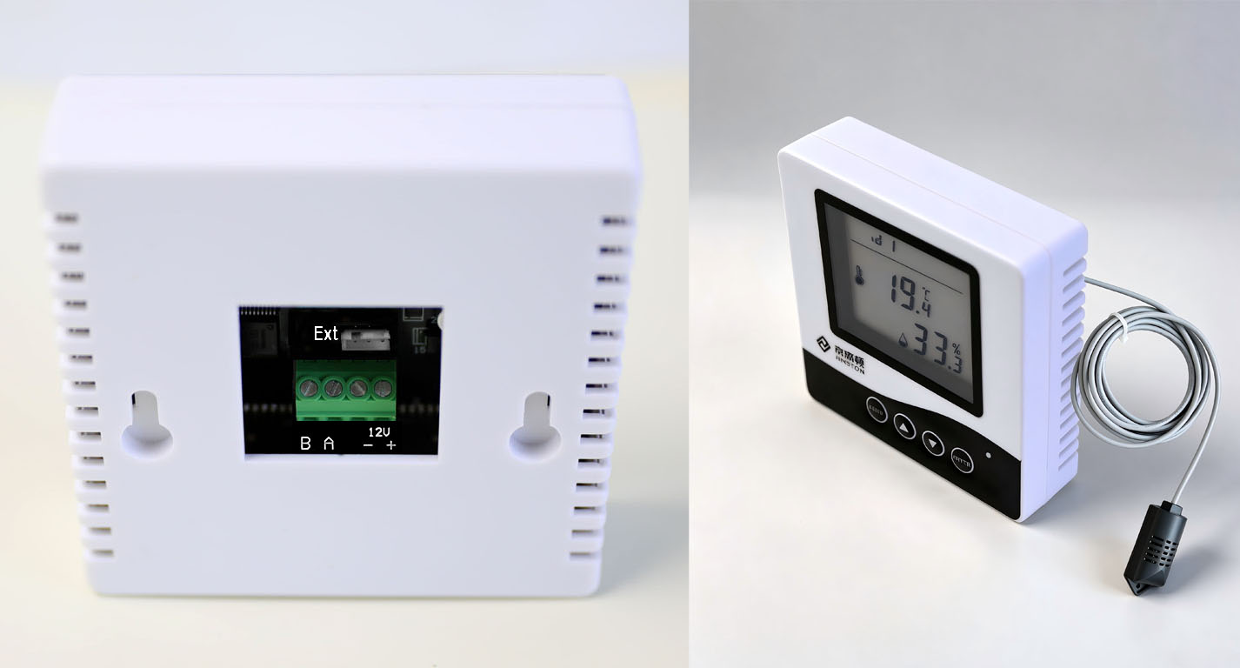

Port Description:
As shown in the diagram, from left to right, the ports are labeled:
‘B’, ‘A’, ‘-’, ‘+’, ‘Ext’
Ext: External Probe
B: RS485-
A: RS485+
- : DC12V power negative
+ : DC12V power positive

Installation Instructions:
- No need to remove the sensor’s front or rear cover during wiring.
- Factory default parameters: Device address = 1, Baud rate = 9600.
- RS485 communication requires correct polarity; reversed wiring will prevent communication.
- DC12V power requires correct polarity; reversed wiring will prevent the device from working.

2. Button Operation Instructions
1. Default Display
The default display shows the sensor ID at the top, temperature and humidity in the middle, and four buttons at the bottom: Menu, “+”, “-”, and Confirm.
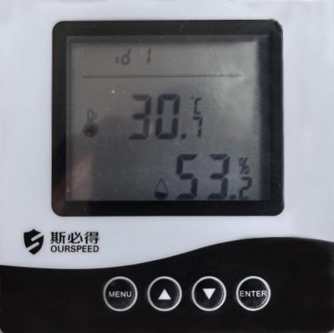

2. Setting the Sensor ID
- Long press the Menu button (~3s) to enter the ID setting page.
- Short press Confirm to make the ID number flash.
- Use “+” or “-” to adjust the ID (range: 1–255). Short press changes by 1; long press changes quickly.
- Long press Confirm (~3s) to save; short press Confirm cancels.
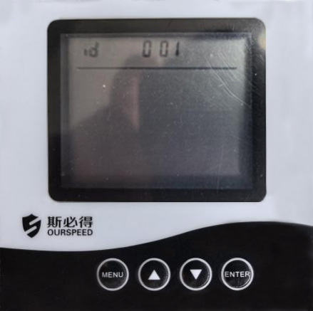

3. Setting the Baud Rate
- Long press Menu (~3s) to enter ID setting, then short press Menu to enter the baud rate setting page.
- Short press Confirm to make the baud rate flash.
- Use “+” or “-” to select among 2400, 4800, 9600, 19200.
- Long press Confirm to save; short press Confirm cancels.
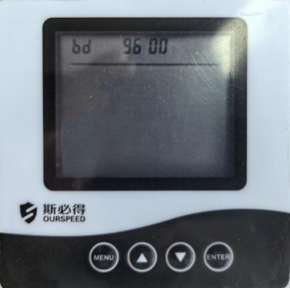
4. Setting Temperature Upper/Lower Limits
- Long press Menu (~3s) to enter the menu, then short press to reach the limit setting page.
- Short press Confirm to make the value flash.
- Use “+” or “-” to adjust the range: -20 ~ 99°C.
- Upper/lower limits constrain each other (e.g., if lower limit = 10, upper limit must be ≥ 10).
- Long press Confirm to save; short press cancels.

5. Setting Humidity Upper/Lower Limits
- Same procedure as temperature limit.
- Adjustment range: 0–99% RH.
- Upper/lower limit constraints apply similarly.

6. Setting Temperature/Humidity Calibration
- Long press Menu (~3s), then short press until reaching calibration pages.
- Short press Confirm to make the calibration value flash.
- Use “+” or “-” to adjust.
- Temperature calibration range: -2 ~ 2°C
- Humidity calibration range: -20 ~ 20% RH
- Long press Confirm to save; short press cancels.

3. Modbus Register List
(Read Function Code 03, Write Function Code 06)
Address | CMD | R/W | Description | Data Type | 倍率 | Range
0 | 03 | R | Temperature | Signed Int16 | x10
1 | 03 | R | Humidity | Signed Int16 | x10
2 | 03 | R | Temperature Upper Limit Alarm Flag | Int16 | 1 | 0-1（1=alarm）
3 | 03 | R | Temperature Lower Limit Alarm Flag | Int16 | 1 | 0-1（1=alarm）
4 | 03 | R | Humidity Upper Limit Alarm Flag | Int16 | 1 | 0-1（1=alarm）
5 | 03 | R | Humidity Lower Limit Alarm Flag | Int16 | 1 | 0-1（1=alarm）
1000 | 03 | RW | Temperature Upper Limit Setpoint | Signed Int16 | x1
1001 | 03 | RW | Temperature Lower Limit Setpoint | Signed Int16 | x1
1002 | 03 | RW | Humidity Upper Limit Setpoint | Signed Int16 | x1
1003 | 03 | RW | Humidity Lower Limit Setpoint | Signed Int16 | x1
1004 | 03 | RW | Baud Rate | Int16 |  | 2400 、4800、9600 、19200
1005 | 03 | RW | Device ID | Int16 |  | 1-255
1006 | 03 | RW | Temperature Calibration | Signed Int16 | x10 | -20 ~ 20
1007 | 03 | RW | Humidity Calibration | Signed Int16 | x1 | -20 ~ 20
1008 | 03 |  | Reserved
1009 | 03 |  | Reserved
1010 | 03 | R | Version Number |  |  | Default 11H

4. Technical Specifications

Model: SPD-TH485-EXT
Manufacturer: Guangzhou Speed Electronics Technology Co., Ltd.
Dimensions: 86 × 86 × 25.5 mm
Power Supply: DC12V
Current Consumption: <10mA
Interface: RS485
Protocol: Modbus
Baud Rates: 2400, 4800, 9600, 19200
Communication Parameters: 8-N-1 (8 data Bits, No Parity, 1 stop bit)
Temperature Range: -40 ~ 125°C
Temperature Accuracy: ±0.3°C
Temperature Resolution: 0.1°C
Humidity Range: 0–100% RH
Humidity Accuracy: ±3% RH
Humidity Resolution: 0.1% RH
Operating Environment: -20 ~ 80°C

- Technical Support
Website1: http://www.lot-speed.com
Website2: http://www.sensor12345.com
Email 1: support_jerry@ourspeed.com
Email 2: sales@ourspeed.com

5. Version Update Log

Version | Changes | Date
V1.2 | 1. Added temperature and humidity limit alarm flags.  2. Adjusted Modbus register addresses for temperature limits.  3. Adjusted Modbus register addresses for humidity limits.  (Applies to firmware version V20H) | 2024-08-27

